# 1. Organization Overview

* Name: JOYS OF ICE CREAM (EAT, LIVE, BREATH ICE CREAM)
* JOYS OF ICE CREAM was established in DECEMBER 2024, and our mission is to have as many stores as possible countrywide. We believe in people having a sweet day and one better way to achieve that is through our sweet ice creams.
* Anyone whether old or young, who LOVES ice cream can just stop at our physical store or our online store to have a taste of our ice creams.
* Our Mission:

To unite people through our ice creams and give out the best tasting ice creams and come up with a wide range of ice cream flavors.

* Our Vision:

To expand our business in future countrywide and to also export our products nationwide. (

## 2. Website goals and objectives

* Our goals for the website created is to reach a larger audience to grow our business and to also showcase the different ice cream flavors we have in our business.
* Mean time spent on the website, Immediate exit rate, duration of the page load, number of times an individual takes a particular and user interactions per visit ()

### 3.Proposed Website Features and Functionality

* Homepage:

This is the starting page created to attract visitors and inform them about the website’s main theme. cmlabs( 2024)

* About Us:

This is the page where we are going to tell our customers more about us, when our business was started, who started the business.(Dublono, 2024)

* Contact Page:

We’ll be having our contact there

* Enquiry page:

This page will be for visitors to enquire about our organization.

* Services/Products sold:

For this page visitors are going to see the different types of ice crems sold.

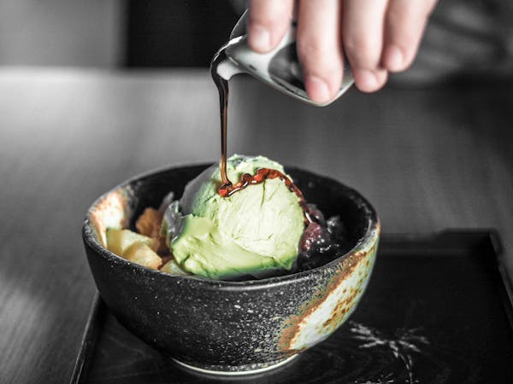

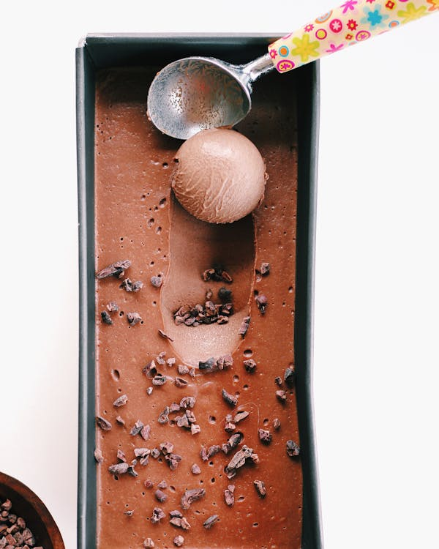

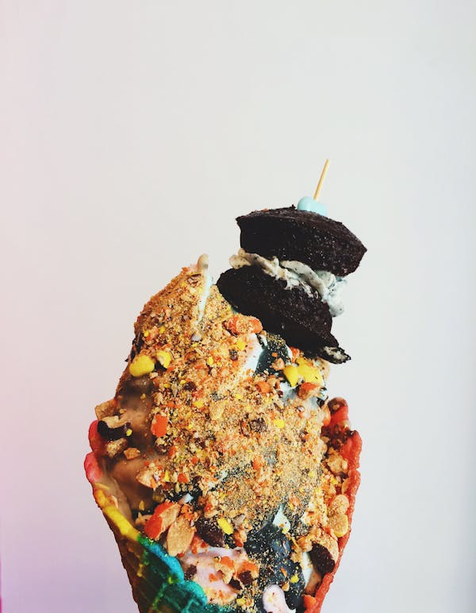

* Contact Page:

We’ll be having our contact there

* Enquiry page:

This page will be for visitors to enquire about our organization.

cmlabs. (2024), “What Is Website Homepage? Definition, Function, and Example”, *Online*, available at: <https://cmlabs.co/en/seo-terms/website-homepage> (accessed 2 April 2025).

Dublono, J. (2024), “Yes, your small business needs an ‘about’ page”, *(Online)*, available at: <https://www.business.com/articles/importance-of-about-page-on-website/> (accessed 2 April 2025).